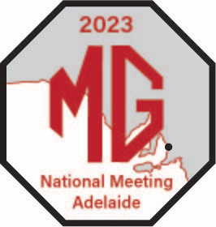
2023 MG National Meeting 7-11 April
July Update
Uwww.natmeet2023mgcc.com.au/

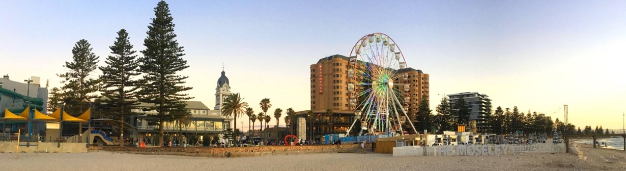
The months are really flying by as we head towards next Easter’s National Meet in Adelaide and already, we’ve had more than 100 expressions of interest. It’s a terrific result but please keep them coming in.

Registration is scheduled to open early next year but we’ll be keeping you closely informed between now and then on what you can expect.

There’s more info on the National Meet website shown at the top of this bulletin, and names, e-mail contact and phone details for expressions of interest should be sent to our Registrar, Chris Bray, at Registrar2023natmeet@adam.com.au

If you have already done this, encourage your friends to send their details.

And a taster of how the organisation is coming along . . .

- The all-important sponsorship is going well and no doubt many of you will be pleased to hear we have a wine sponsor – crucial when you’re coming to the Wine State!
- Key events like the Concours, Motorkhana, Super Sprint, Observation and Social Run, and the Kimber Run are all well in hand
- So are the social events including the Theme Party night: next year the theme will be ‘Disney Characters’ (a push to make the theme Port Adelaide Football Club fell short by quite a margin)
- We’re close to finalising designs for the NatMeet regalia
- All venues are locked in.

Easter accommodation is always in high demand so please book early to avoid disappointment. MGCC SA cannot make bookings on your behalf.

The next update will be September, in the meantime please send any enquiries to:

Tim Edmonds, President, Chairman2023natmeet@adam.com.au
Chris Bray, Registration, Registrar2023natmeet@adam.com.au
Sandra Cardnell, Secretary2023natmeet@adam.com.au

See you in Adelaide next Easter!!

Cheers,
Tim Edmonds
President, MG Car Club of SA.

